Endurance GB – Lancashire Group
CROAL IRWELL SPRING NATIONAL
SUNDAY 15TH APRIL

VENUE – OUTWOOD COUNTRY PARK, OFF ST JAMES, RADCLIFFE, M26 1AG.
EMERGENCY CONTACT NUMBER: 07570 880233 – CATH HOUGHTON

Dear
Bib No:
Class:
Vet times: Class 1 – 09:00
Class 2 – 09:00
Class 3 – 09:30
Class 4 – 09:45
DIRECTIONS: From M60 leave at J17, follow signs to Whitefield/Radcliffe. Take left lane at 3 way set of traffic lights and 50yds filter left with sign for Kearsley. Straight on through next set of lights. At next lights turn left (there is a filter light here). This brings you onto Ringley Road. Follow the road for approx. 1 mile, then turn right at the Hare and Hounds Public House onto Outwood Road. Go down the hill for about ½ mile, then left onto James Street. Follow the track through the gates to the venue
Directions: From M61 leave at Junction 3, bear left on to the A5063/666. Stay on inside lane, and take the exit. At the roundabout take the 3rd exit on to A666. In approx. 800yds at the 1st set of traffic lights turn Left A667 Whitefield on to Stoneclough Road. Approx. 2 miles further turn Left A665 Radcliffe (Hare and Hounds on corner) on to Outwood Road. Go down the hill for about ½ mile, then left onto James Street. Follow the track through the gates to the venue
Directions Leaving Venue using M61: Turn Right on to Outwood Road. At T junction turn left. At mini roundabout take 2nd Exit. At lights Turn right. Move to the outside lane, at the lights turn right, stay on outside lane. At roundabout take the 3rd exit on to M61

PARKING:
- 7.5 tonne lorries, please utilise the small car park just through the gates on the right. If full then please drive onwards to car park
- Trailers and 3.5 tonne boxes drive to main car park. We will commence parking from the bottom of the venue towards the entry/exit
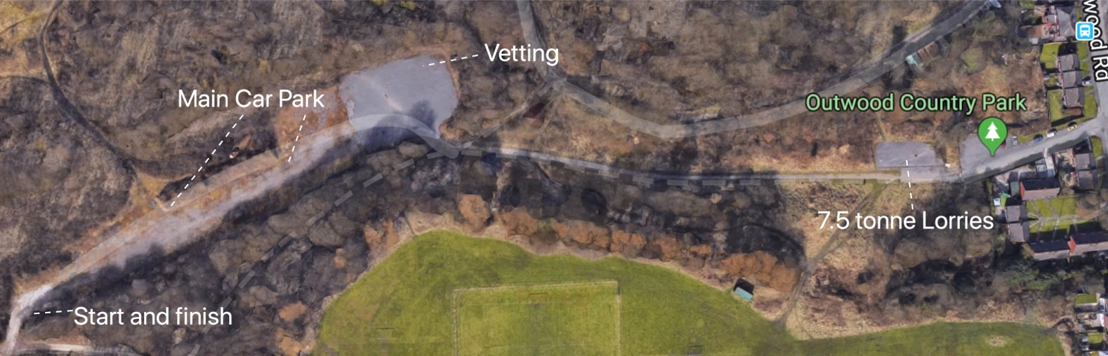
IT IS IMPERATIVE that everyone obeys the instructions of the stewards to ensure the way is clear for the safety of all
PLEASE BE CONSIDERATE to other users of the multi-use parks AT ALL TIMES whilst riding, crewing and in vehicles. You will be sharing the route with other horse riders, walkers, cyclists, dogs and children, slow down and pass other users with Caution.
NO smoking or lighting of fires in the forestry areas
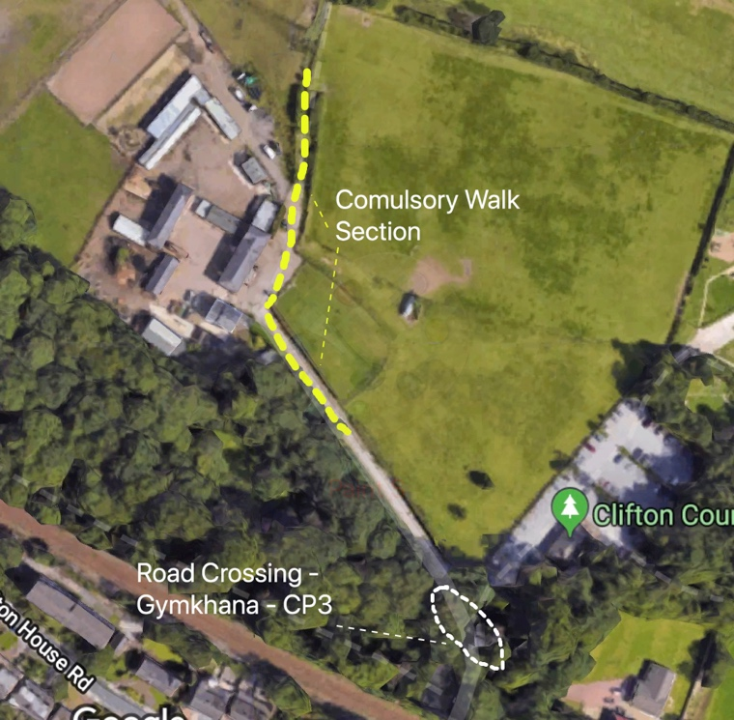
32km GER and PR – There is a small local gymkhana taking place at Clifton Country Park (CP3****) Please follow the instructions of the stewards. This will then take you into Old Clifton Farm which is a Livery Yard and will be a compulsory walk section. The gate on the PRoW will be manned and opened by stewards.

The route will be marked with Orange Spray and Red/White tape. ALL MARKERS WILL BE ON THE LEFT HANDSIDE. If they are on your right there is a problem. You could be going in the wrong direction, or the markers have been moved
Please check NOTICES at Secretary’s area for additional instructions and information, route changes or hazards before commencing the ride.
Please ensure your horse has the appropriate ribbon. Please all be aware of the significance of the coloured tail ribbons and take care when approaching horses displaying RED horse may kick; GREEN Young, inexperienced or Novice horse; BLUE stallion. Please be aware that stallions should wear stallion bridle discs as provided by EGB. There are likely to be young and inexperienced horses at the ride and riders new to the sport. Please show consideration when approaching and passing other horses.
Please BE AWARE when leaving the start that riders may be approaching from your right
Dogs should be kept under control and on leads. Please note that owners who have dogs on extendable leads need to be in control of the dog.
Horses should NOT at ANY time be left unattended whilst tied to the trailer or horse box. Horses are not permitted at the secretary’s office
PHOTOGRPAHER: Ruth Saunders, IndiePics will be available for purchase after the ride. www.indiepics.co.uk
CATERING: All Day hot and cold snacks and beverages from Dolly P’s
IMPORTANT

This ride is held within multiple Parks and the trails are not detailed on maps, please follow the markers. If you come across a problem that we haven’t seen, or markers have been abused, please ring the emergency contact number.
AFFILIATION
This ride is run under the Endurance GB Rules

FOR INSURSANCE REASON RIDERS CANNOT HAVE CAMERAS ATTACHED TO HELMETS

DISCLAIMER LIABILITY
Save for death or personal injury caused by the negligence of the organisers or anyone for whom they are in law responsible, neither the organisers of any event to which these rules apply, nor Endurance GB, nor any agent, employee or representative of these bodies accepts any liability for any accident, loss, damage, injury or illness to horses, owners riders, spectators, land or any other person or property whatsoever whether caused by their negligence, breach of contract or any other way whatsoever.
RESERVATION OF RIGHT
The organiser has the right to cancel the ride or any class; alter the advertised times; refuse an entry, with or without stating the reason
HEALTH AND SAFETY
The organiser/organising committee of this event has taken reasonable precautions to ensure the health and safety of everyone present. For these measures to be effective, everyone must take all the reasonable precautions to avoid and prevent accidents occurring and must obey the instructions of the organiser/organising committee and all officials and stewards

Thanks
Cath Houghton – Ride Organiser

Crew Information

There are 2, and if you are quick 3 crew points on the route
Crew Point 1
Lumns Lane: Exit from Forest Bank Park – It will take you approx. 15 mins to get there
The exit from the park is opposite Viridor Recycling
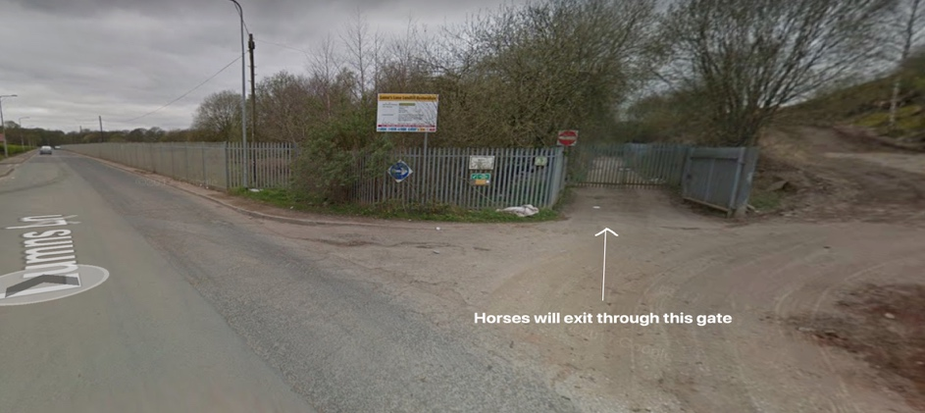
Post Code: M27 8LN

Crew Point 2
Is at CP3 - Old Hall Road Junction Phillips Road
These are the directions from the venue turn right on to Outwood Road – at the T junction. Turn left on to Ringley Road. Turn Right on to Old Hall Road (about ½ mile) Keep right and stay on Old Hall Road, down a bumpy road, past the stables. At the T junction turn left on to Phillips Park Road, go as far as you can and park up. The riders will approach you from the slope and go past you on to Old Hall Lane.
Sat nav may take you various route and 1 of them is by M60! – will take you approx. 20 mins
Postcode M45 7EH

Crew Point 3
If you are quick enough you can get back to the venue from CP3, about 5 mins, and slosh at Point F, before they do final loop back to the venue!

