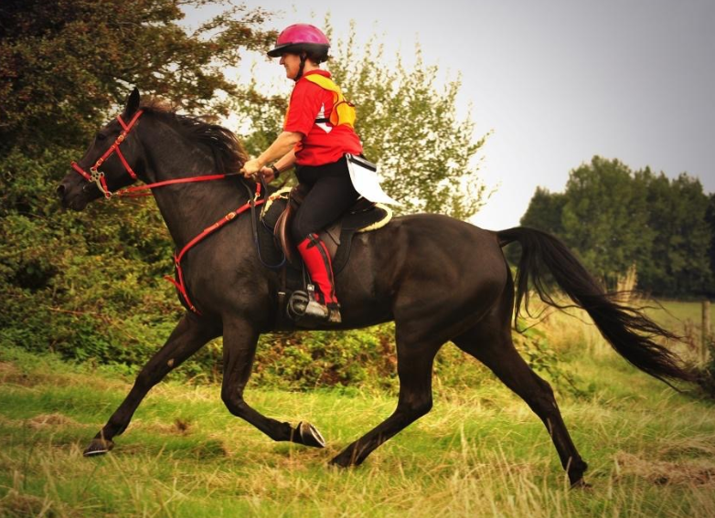
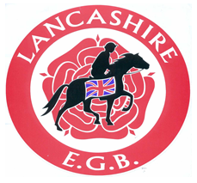
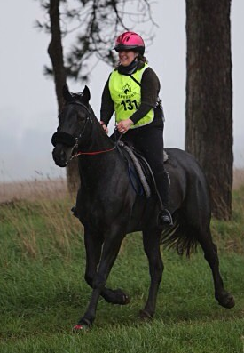

Rider name:

Horse/Horses names:
Age: | Breed:

Crew:

Trophy won at Lancashire Presentation evening:

Aims for 2015 season:

How did you get involved in Endurance & why do you and you horse enjoy it:

What do you think about when it’s just you & your horse together on the trail:

Furthest distance driven to an event, to ride what distance:

Other hobbies:

