

NEWSLETTER



DECEMBER 2015

Editor’s Bit
Here we are, the final newsletter of the year – how time flies! This edition, as always, is mainly about the Annual Awards Night in January and you will find all the information you require for that later on. The other main event at this time of year is renewal of membership and Sue has included necessary information regarding membership for 2016. If you are one of our members who receive a paper copy of the Newsletter you will find enclosed, a form for your Horse Registration, a Membership Renewal Form and a Ride Entry form. The Membership Form is designed to be used on line and therefore has ‘drop down’ boxes that you will need to complete with your own information.
It won’t be too long before the 2016 Ride Schedule is published and we can begin to make serious plans about what we would like to achieve next season rather than just sit and dream as we recover from over-indulgence on Christmas day!
On that note I hope lots of you manage to get to the Presentation Evening at Ribby Hall – it really is a good night, a chance to catch up with other members that you may not have seen since the end of the season and of course the presentation of those lovely rosettes and trophies.
Meanwhile enjoy the Christmas and New Year celebrations.
Regards
Helen

From the Chair …………… 
Merry Christmas & Happy New Year everybody.

It’s that time of year again, the end of the ride season, all the Christmas festivities to look forward to and also the Annual Presentation Evening and the 2016 season coming up fast.
Some of you attended the National AGM and Presentation at the end of November and several of our members did really well and were included in the honours. Whilst some of these were announced on Facebook and our Lancs Group Website, I think a couple were missed off so we have included a full list of our prizewinners later in the newsletter to make sure that everyone gets a mention.

Talking Presentation Evenings, I hope that you all remembered to send off your completed Ride Cards by the due date; these are all currently being checked, calculated and entered into the various awards categories – all will be revealed on Saturday 23rd January at the Lancs Annual Presentation Evening. The details about that are included later in the newsletter along with your ticket booking form. Please take note of the dress theme this year – Red Ties and Tiaras!!!!!!! Please make every effort to attend, and try to bring some of your family and/or friends along as well to help us all celebrate our achievements. We would love to make it as enjoyable an evening as last year.


I was pleased to see a good number of members at our Lancs AGM in
November. We had a really good discussion about our group, our sport and our proposed rides and activities for next year. We also had a laugh and a bit of fun with the quiz, and I think everyone enjoyed the wonderful chip and butty supper that the club put on for us.
One of the things that did help this year was the introduction of our ride helper scheme. I know that it caused some concern (and possible disgruntlement in some quarters), but it really does seem to have worked well. Remember it was never intended to be a punishment, but was a necessity to allow us to continue to put on the number of rides we have. It really wasn’t fair that all the work was placed at the feet of the same people all of the time. It is only right that if you are competing in our sport, you contribute and put a little bit back by helping in at least one ride. So it is wonderful that just about all our riding membership came up trumps and managed to help – and that’s what filled our ride schedule and that will hopefully continue next season as well. Even more favorable - it was great to hear the comments of some of the newer helpers in that they did actually enjoy the experience and found it was a pleasant change to see things from the other side. Quite enlightening in some cases as well isn’t it???? So congratulations to everyone who made the scheme work – well done!

Please don’t forget as the next season approaches that we need to renew our memberships. Both full and associate members can renew online on the National EGB website but Associate members can still download the paper form to send to Jean Merchant (address on form from Lancs EGB website). All of us – both competitive and pleasure riders - need to download a Lancs Horse Registration Form from the website to send to Jean Merchant in order to receive a Horse Ride Record card to log all the rides you will do next season. Don’t forget to do this as it really is important – these are available online now.

Well, all that considered I will leave you to enjoy the festivities. Make the most of the ‘off season’ and enjoy a brief rest before the next season starts. I hope that you all have a wonderful time over the Christmas period and I look forward to seeing you at the Presentation Evening – remember to send in your ticket requests.
Happy Christmas everyone
Sue

Success for Lancs Group Riders at the National EGB Awards Evening
Lancs Group Riders were placed in the EGB National Awards as follows:-

The Whitbridge Merlin Memorial Trophy : 1st Place to Kate Atkinson & DNS Ronaldo.

Pleasure Pairs Trophy: 1st Place to Jamie Houghton & Max paired with Sarah Bamber & Kitty.
Pitchford Trophy: 2nd Place to Carolyn Cummings & Peterbrook Sunset Surprise.

Winward Best New Horse Trophy: 2nd Place to Jackie Lloyd and Khalifa BJ.

G Putnik Trophy: 2nd Place to Anne Booth & Rassam.

Teams of Three Trophy: 3rd Place to The Lancashire Rose and her Thorns i.e. Phil Cooper & Shannon, Karen Corr & Riyah Raquassah, Bond Hardman & Hamra bint Krayann.

Junior Championship –Merrie Trophy: 5th Place to Max Wilson & Hilin Dollar.
6th Place to Lily Gibbons & Sandy W.

Novice Championship – Mira Trophy: 6th Place to Jackie Lloyd and Red House Lily Marlene.

Well Done to all of you.

I think we have included everyone there but please let us know if anyone has been missed off.

Endurance GB Lancashire Group


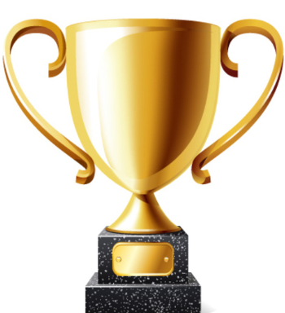
Annual Awards Presentation Evening
Saturday 23rd January 2016

This year’s presentation evening will again be held at Ribby Hall near Kirkham. This has been a very successful venue for us over the last few years, as it has a pleasant atmosphere and the food and staff service are excellent. A slight change this year however, in that we have a different room to accommodate our growing numbers. This year we will be in the Woodland Suite which is slightly larger and has a bar within the function room itself which should make things easier for everyone.

This year’s guest who has kindly agreed to come and present the awards is local vet Karen Archer from Oakhill. Karen has vetted at our Lancs Group Competitive rides for the last few years and is known to many of you. So please make every effort to come along. Also try to encourage your family and/or friends to come with you to help you to enjoy the evening. This invitation is especially true for some of our newer members to the group; please do come and join us and take the opportunity to meet some of the other members. It really is a good chance to get to know everyone, in more leisurely circumstances than at a competition or ride. It is usually a good night for all!

A route map and directions to Ribby Hall, will accompany the tickets when they are sent out to you, but it is easy to find being directly off the M55 Junction 3. Please read the menu below and make your selection on the attached form ASAP – it is important you send in your ticket request by 16th January AT THE LATEST! The price per ticket is £23 per person for the three courses, plus coffee or tea etc. This really is good value as the food is usually excellent, so please do take advantage of the offer and support your group by buying tickets and coming to what should be a very enjoyable social evening – not to mention picking up your rosettes and prizes. If there are friends you wish to sit with please list them at the bottom of the form and I will do my best to accommodate you on the seating plan.

The menu for the evening is as follows:-

Please choose one option from each course to create your menu

Starter
Leek and Potato Soup
with Lancashire Cheese Croute

Chicken Liver Paté
Sour-dough Crostini, Onion Jam

Garlic & Herb Stuffed Field Mushrooms
Brioche, Tarragon Hollandaise



Main Course
Slow Cooked Medallion of Durton Meadow Beef
Onion Puree, Mashed Potato, Rosemary & Red Wine Jus

Roast Breast of Chicken
Tarragon Rosti, Peas, Onions & Smoked Bacon Cream

Seared Salmon
Pea Veloute, Confit Cherry Tomatoes, Crushed Potatoes

Savoury Pancakes
With Wild Mushrooms and Leeks, Goats Cheese Sauce
All served with Roasted New Potatoes & Seasonal Vegetables

Sweet
Sticky Toffee Pudding
Toffee Sauce, Madagascan Vanilla Bean Ice-cream

Oreo and Milk Chocolate Cheesecake
Chocolate Popping Candy, Caramel Crunch Ice-cream

Lemon Meringue Tart
Cassis Sorbet, Fresh Raspberries



Freshly Brewed Tea or Coffee and Chocolate Mint Wafers
£23.00 per person

Dress theme - Red Ties and Tiaras
Please indicate your choice of menu on the form enclosed, and send your completed form, together with a cheque made payable to EGB Lancs Group for £23 per person, and a STAMPED ADDRESSED ENVELOPE, to me (Sue Taylor-Green) by 15th January 2016 AT THE VERY LATEST!!!!!!
N.B. It is probably worth you making a note of your choices
on the above menu to remind you what you have selected!

As usual we will also end the evening with a ‘ Rowdy Raffle’

We have had some generous quality prizes donated for the last couple of years. It would be great if we can keep this standard going, so I would like to appeal to all members, especially if you have a business from which you could donate your product or time. Anything equine would be great e.g. Tack, riding lesson/training, maybe a weekend accommodation for horse and rider. Or are you a hairdresser, beautician, butcher, baker, even candlestick maker!! Anything that you think will be a quality usable prize.
We would be pleased (and grateful) to hear from anyone with an idea or offer of a raffle prize. Please contact lindacowperthwaite@tiscali.co.uk or myself suetaylorgreen@hotmail.com. Or just turn up with it on the night.
Also if you have a trophy from last year’s presentation, would you please arrange to get it back to me, by the week before the “do” (i.e. by 16th January) or phone me to let me know how you are getting it to the Awards ceremony.
Thanks
Sue Taylor-Green
01772 436043

DISCLAIMER ANY COMMENTS MADE IN LETTERS RECEIVED FOR INCLUSION IN THIS NEWSLETTER ARE NOT NECESSARILY THE VIEWS OF THE EDITOR OR MEMBERS OF THE EGB LANCASHIRE GROUP COMMITTEE
You are welcome to contact any of the committee but if your query is specific to one of the listed roles, then we suggest you contact the appropriate Committee Member, in the first instance.

Committee

Chairperson:
Sue Taylor-Green, Nursery Cottage, Ulnes Walton Lane, Leyland, Lancs PR26 8LU. Tel: 01772 436043 / 0787 664 7578 suetaylorgreen@hotmail.com

Vice-Chairperson/Membership Secretary:
Jean Merchant, 259, Rochdale and Bury Old Road, Heywood, Lancashire, OL10 4BQ. Tel 01706 364360

Minutes Secretary and Group Liaison:
Yvonne Clark, 5 Woodland View, Broadclough, Bacup, Lancs OL13 8PD.
Tel 01706 879740 /07779 330930 yvonneclark@btinternet.com

Joint Ride Co-ordinator and Equipment Officers:
Glenda Griffin, Home Farm, George’s Lane, Banks, Southport PR9 8HD
Tel:07714 753576 g.g135lark@hotmail.com

Web Administrator
Pat Kelly, 361 Southport Rd, Croston, PR26 8LQ
Tel: 07734385108 patjkelly@hotmail.co.uk

Treasurer/Members Liaison/PR/Merchandising:
Linda Cowperthwaite
Tel:07742 224 670 lindacowperthwaite@tiscali.co.uk

Newsletter Editor
Helen Dawson, 48 Rectory Lane, Bury, Lancs, BL9 7TA.
Tel: 0161 764 6534 ehd2011@btinternet.com

Trophy Secretary
Deb Bennett, 5 Woodland View, Broadclough, Bacup, Lancs OL13 8PD
Tel: 01706 879740 /07831 810788 deb.bennett1@btinternet.com

Safeguarding
Maxine Lang, Hawthorne lodge, Grange Lane, Stalmine, Poulton-le-Fylde, FY6 OJH Tel 01253 700790 maxinelang@hotmail.com

Rachel Woodruff, Withnell Station, Abbey Village, Chorley, PR6 8DA
Tel: 01254 830900

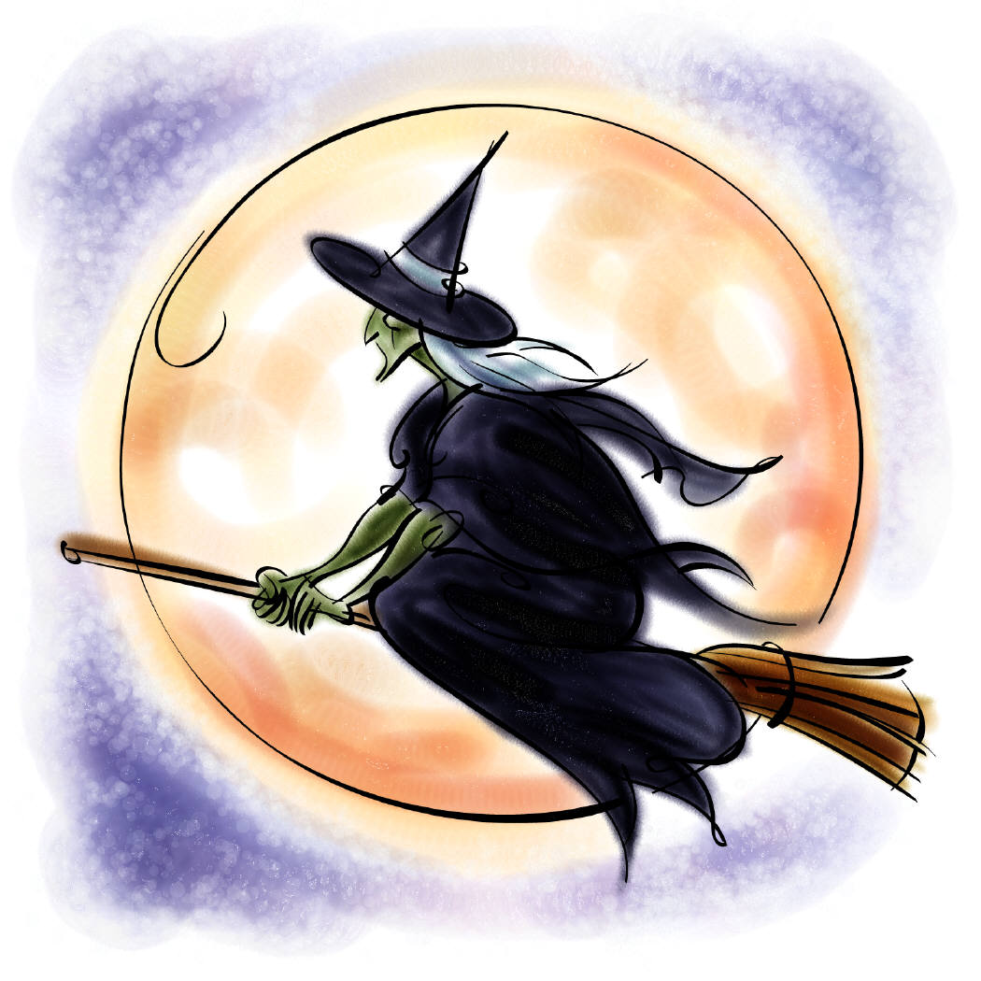

EGB Lancs Group Presentation Evening

Saturday 23rd January 2016

Booking Form

Name_______________________________Phone_______________________

Address _________________________________________________________
___________________________________________________________ ___________________________________________________________

Number of tickets required __________Amount of cheque
enclosed £___________

Please return form, with cheque payable to EGB Lancs Group for £23 per person plus SAE,
To Sue Taylor-Green, Nursery Cottage, Ulnes Walton Lane, Leyland, Lancs, PR26 8LU,
by 14/1/2016 (at the latest)
Tickets will be returned to you together with a venue map, early in the New Year.
Please indicate number required for each of the choices for each course:-

Starter :
Leek and Potato Soup _______
Chicken Liver Paté _______
Garlic & Herb Stuffed Field Mushroom _______
Main Course:
Medallion of Durton Meadow Beef _______
Roast Breast of Chicken _______
Seared Salmon _______
Savoury pancakes ( Vegi option) _______
Desert:
Sticky Toffee Pudding _______
Oreo and Milk Chocolate Cheesecake _______
Lemon Meringue Tart _______

